RESUME
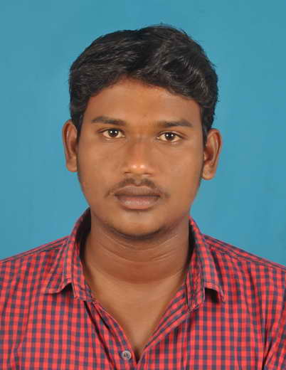

PRAKASH.S
No: 59,4TH MAIN ROAD, 3RD CROSS STREET,
VASANTHAPURI, PERUMALERI,
MAMALLAPURAM – 603104.

Email: karthick7004@gmail.com
Phone. no: +91 9003063398

OBJECTIVE

Seeking a challenging and rewarding career in an organization where I can make significant contribution toward achievement of organization goals and realization of my own potential by focused application of the knowledge and skills that I have acquired.

ACADEMIC QUALIFICATION:
Course | Institution | Year of completion | Board/University | % marks obtained
B.E. (ECE) | ROYAL COLLAGE OF ENGG & TECH | 2014 | Anna University | 67 %
XII | GOVT. HR SEC SCHOOL | 2010 | Tamil Nadu State Board | 73 %
X | St’ JOSEPH’S HR SCHOOL | 2008 | Tamil Nadu State Board | 81.4 %

Experience:
- Working 2 year in HEBRON TRANSPORT at Chennai.
- Company : HEBRON TRANSPORT
- Destination : Booking & Marketing Executive, Dispatching report
- Role : Agent Support
- Experience : 2 years

- Working 2 year in PRAKASH TOURS & TRAVELS at Mamallapuram.
- Company : PRAKASH TOURS & TRAVELS
- Destination : Admin Executive,
- Role : Admin & Agent Support
- Experience : 2 years

- Working 3 year in YBM TRAVELS at Chennai.
- Company : YBM TRAVELS PVT,LTD.
- Destination : Branch Manager,
- Role : Admin & Maintainence
- Experience : 3 years 6 months

TECHNICAL SKILLS:

Software skills : M.S. Office, C,C++, ( DCA), & Bitla, Vahana, bus software handling.
Operating system : Windows XP, Vista, Windows 7, 8,10

FIELDS OF :

Work at international and domestic tour operator, Transport operator, booking handling, Maintainence, Booking executive, Bus operations control, online support, Customer support.

PERSONAL SKILLS:

- Positive minded

- Hard worker

- Quick learning

PERSONAL DETAILS:
Name : Prakash.S
Father name : Mr. S.Shanmugam
Date of birth : 12.04.1993
Gender : Male
Nationality : Indian
Marital status : Single
Languages known : Tamil, English,
Hobbies : Playing & watching cricket

DECLARATION
I hereby declare that all the above information is true to the best of my knowledge and belief.

Yours sincerely,
PRAKASH.S
Place :
Date :

